To prepare computers for CCC we run through a process of wiping the hard drives, disassembling the monitors storing the leads and cables.
To wipe the computers we use DBAN. DBAN is a simple program that can be burnt onto a CD/DVD or loaded over a network,that erases data using industry standard algorithms.
Once the computers are broken down, the main issue is on-site storage.
This procedure works on various SLQ donated computers including HP-8100 and HP-8200 Desktop PCs, HP-Elitebook laptops as well as older Dell computers. If you are having trouble adapting it for your donations, please contact us for a hand.
Your computer will boot and let you choose from a number of options for wiping the drive, ranging from simple to paranoid.
The official version of DBAN doesn't work on all the SLQ donated computers so we've made a build from an unofficial fork, which can be burnt to a DVD.
You can download our build here, then use the archive manager to extract the files.
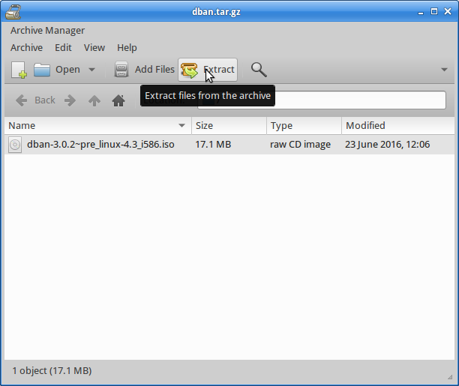de-compress
Find xfburn in the whisper menu.
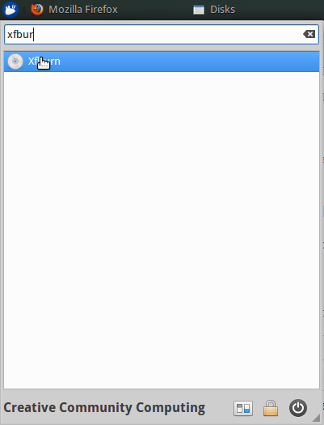launch xfburn
Launch it and select Burn Image
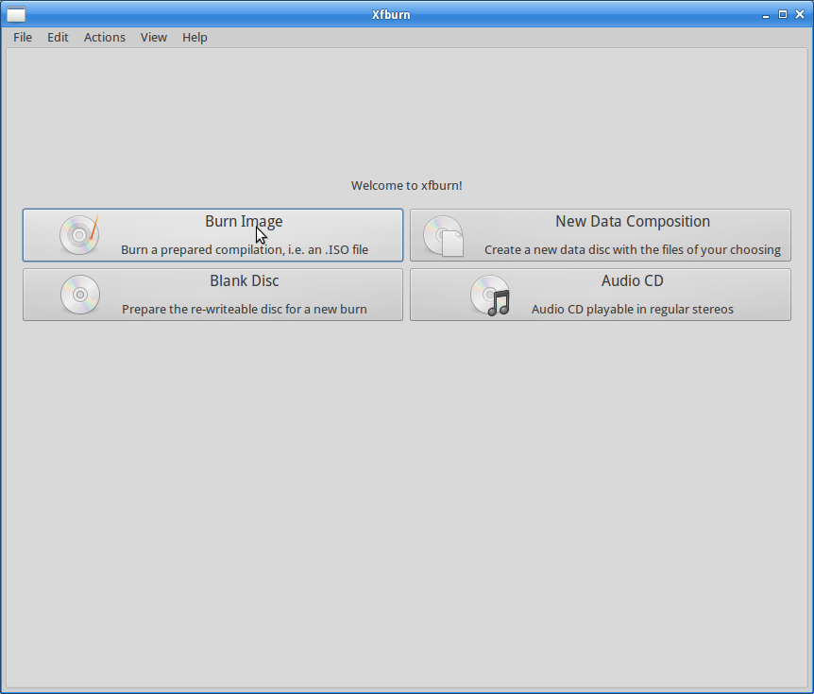burn image
Find your dban.iso - then click burn.
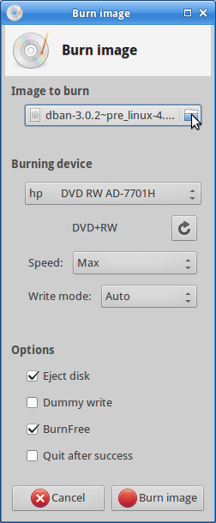find iso
This will take about 5 minutes.
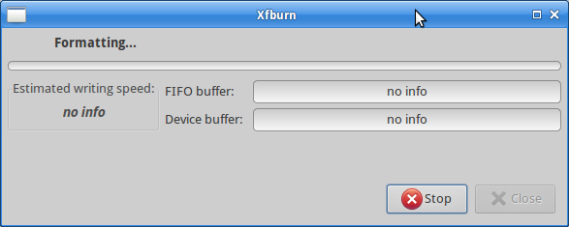burn image
We will demonstrate this using a CCC laptop - specifically HP Elitebook 2570p. The options will vary each new computer but the basic process is;
- Boot from DVD drive
- Load DBAN
- Go to interactive Mode
- Select disks to be wiped
Once your computer is ready to be wiped, start it up then insert the DVD. Interrupt the boot to go to startup options (esc) the select “Boot Device Options”
This procedure will wipe ALL information from the target drive!!!
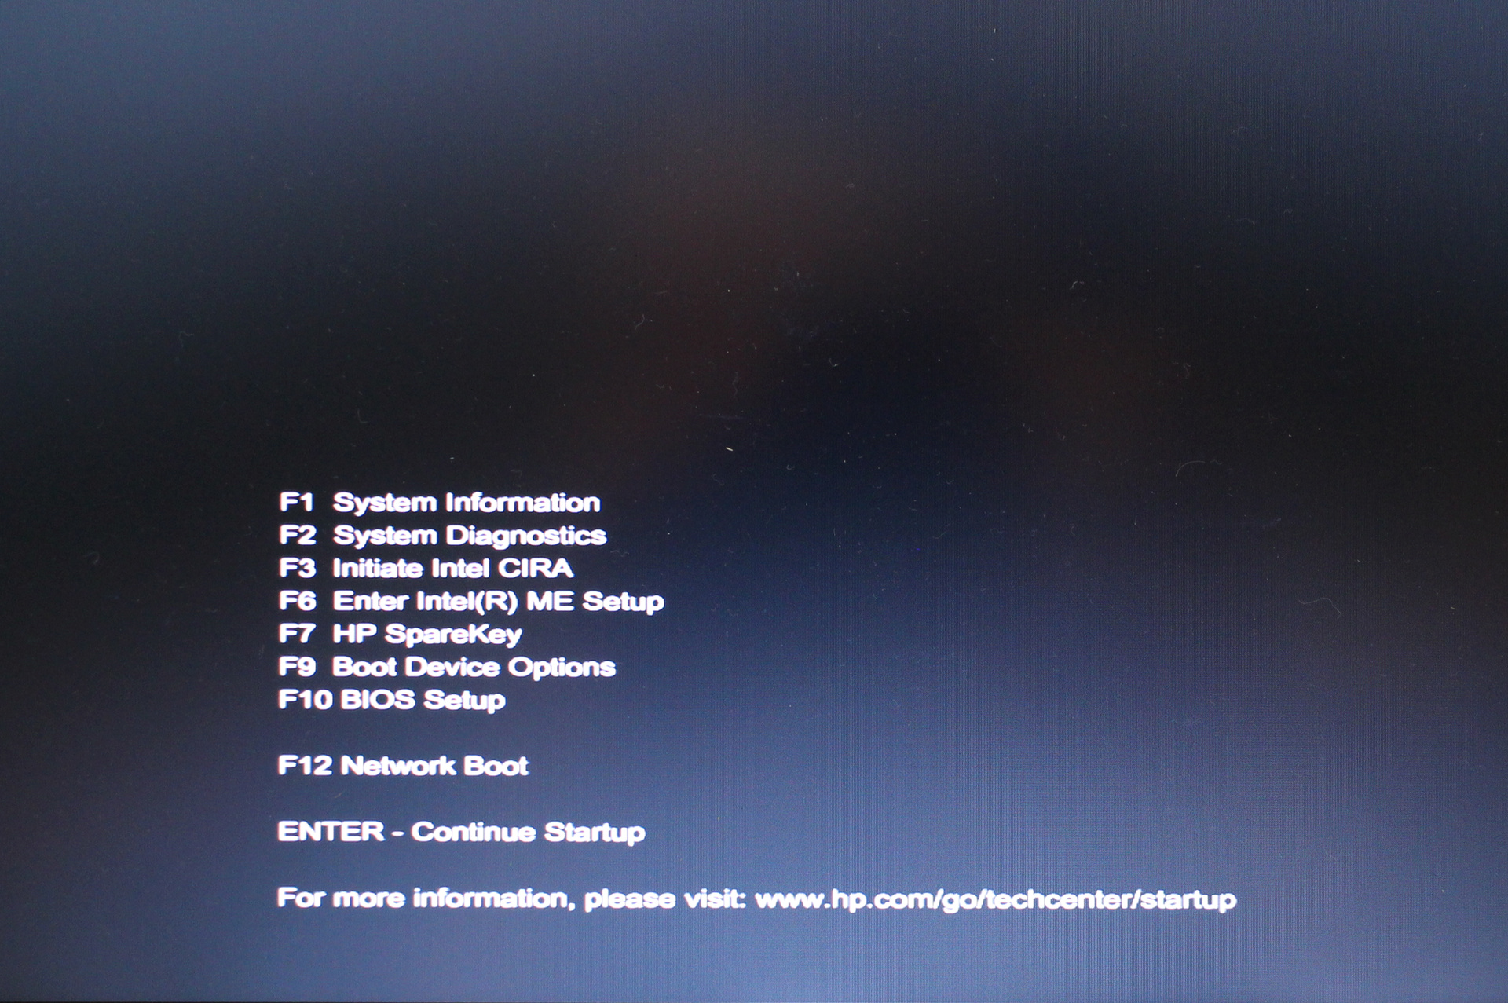
The DVD drive is in the “Notebook Upgrade Bay” for this computer
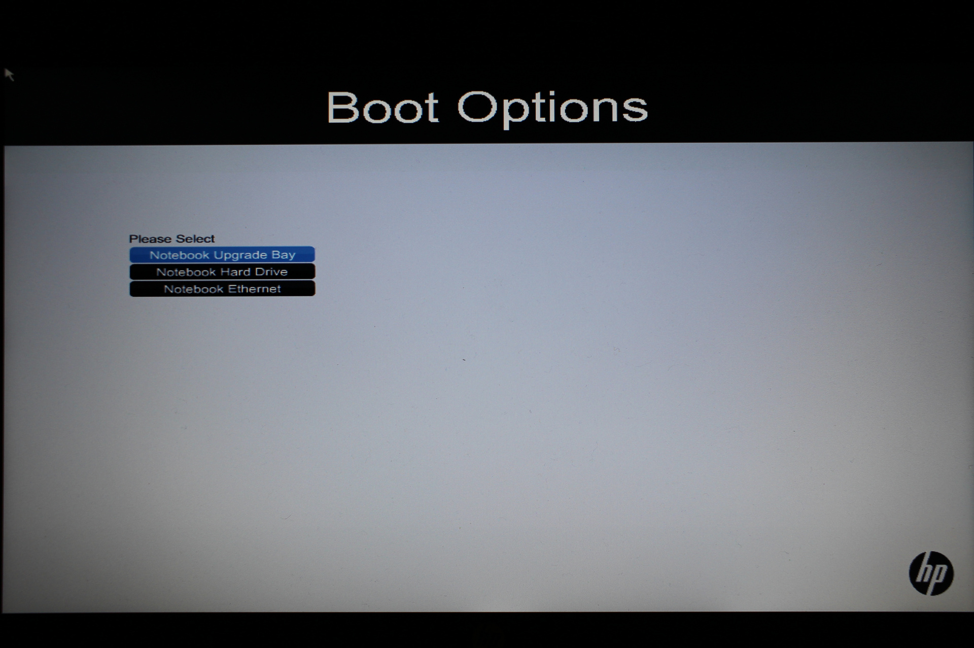
Once DBAN has started, press enter to go to interactive mode
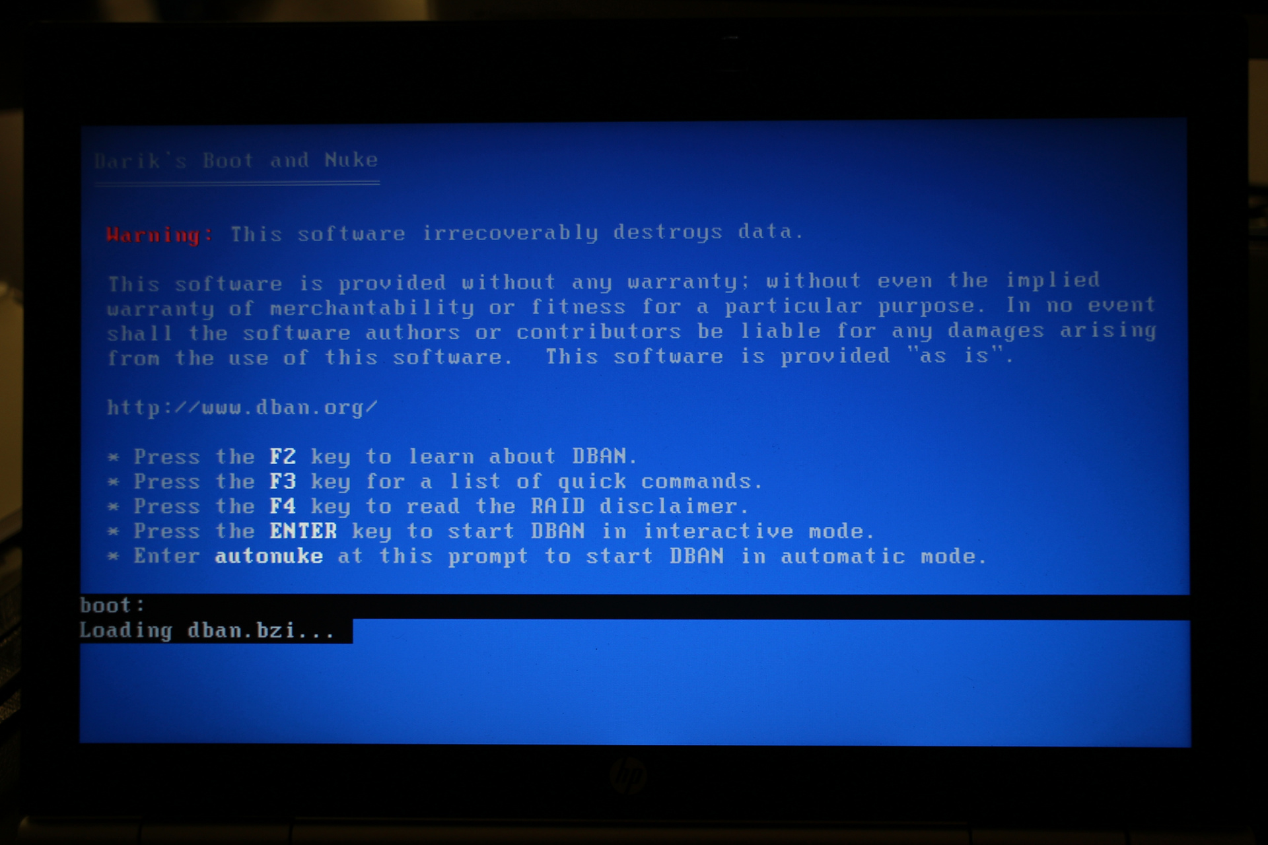
DBAN will finish loading, and scan the computers hardware 1)
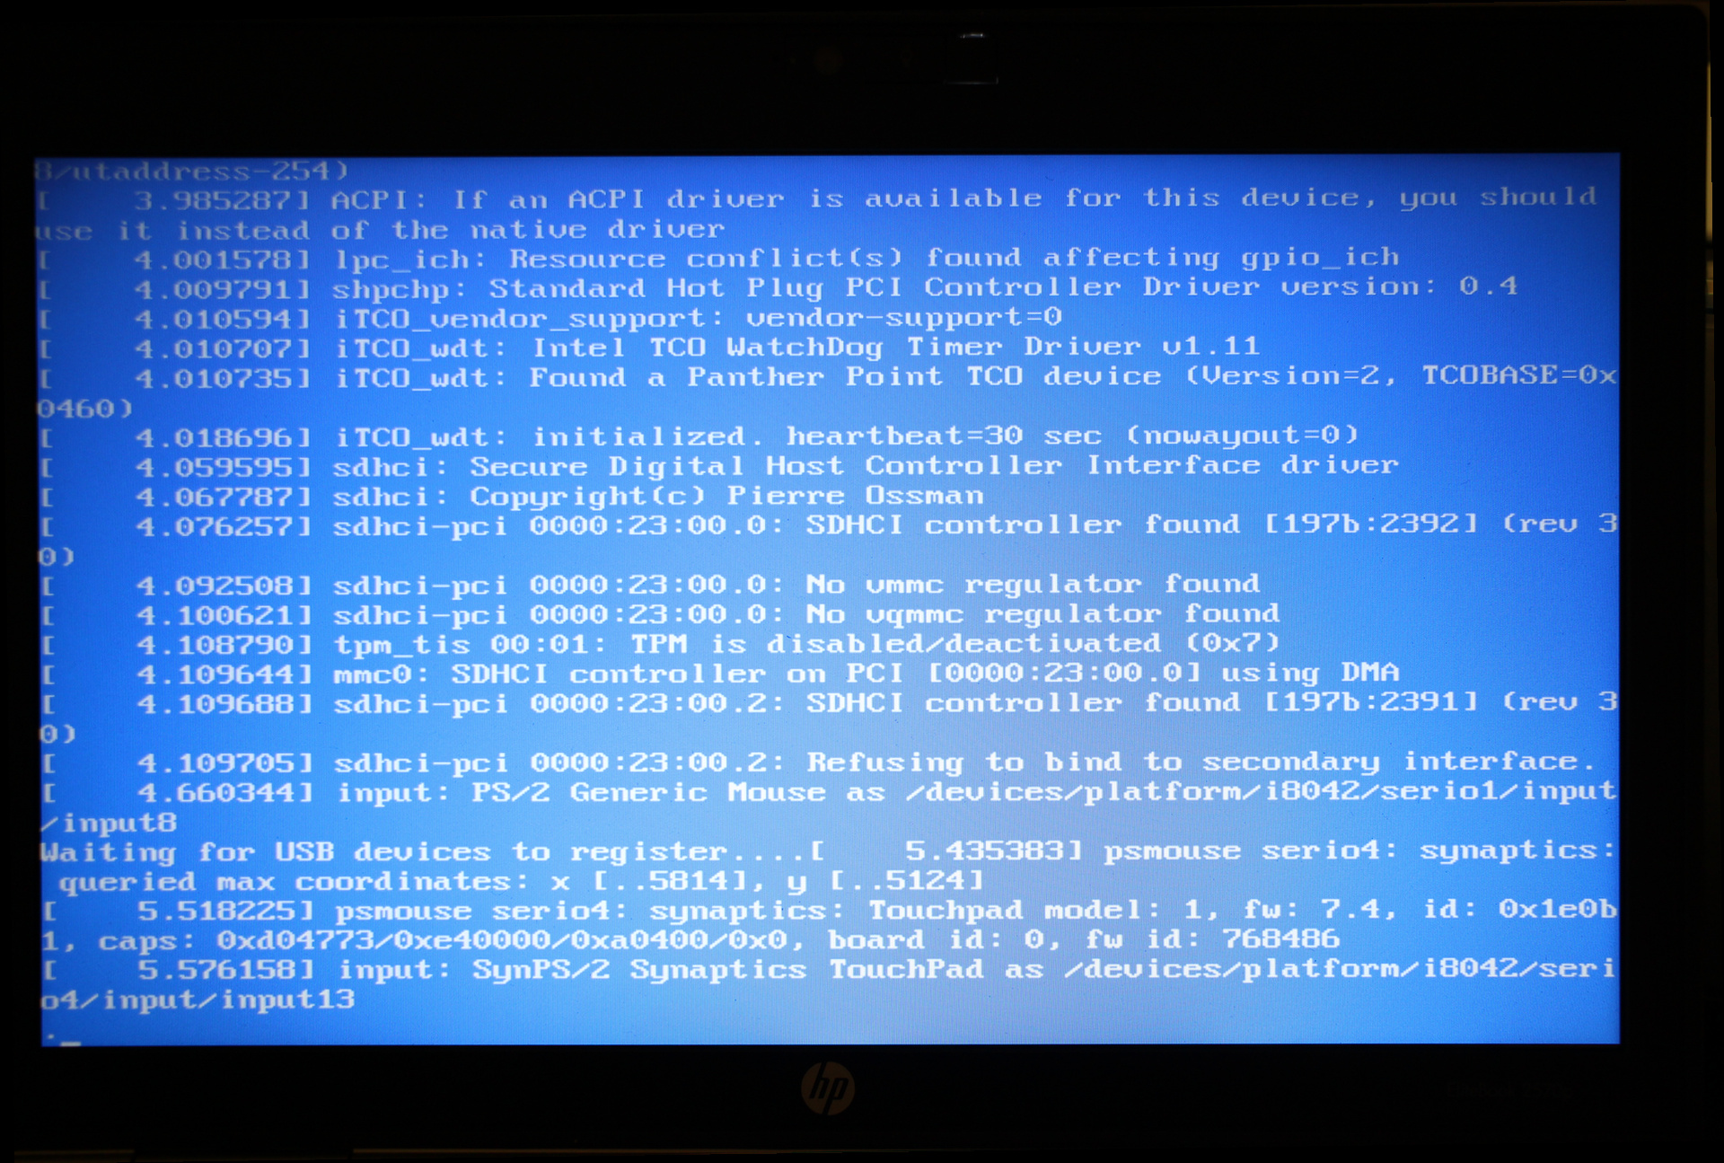
and finish with a screen that allows you to select the drives you want wiped. Make sure all the drives in the computer are visible.
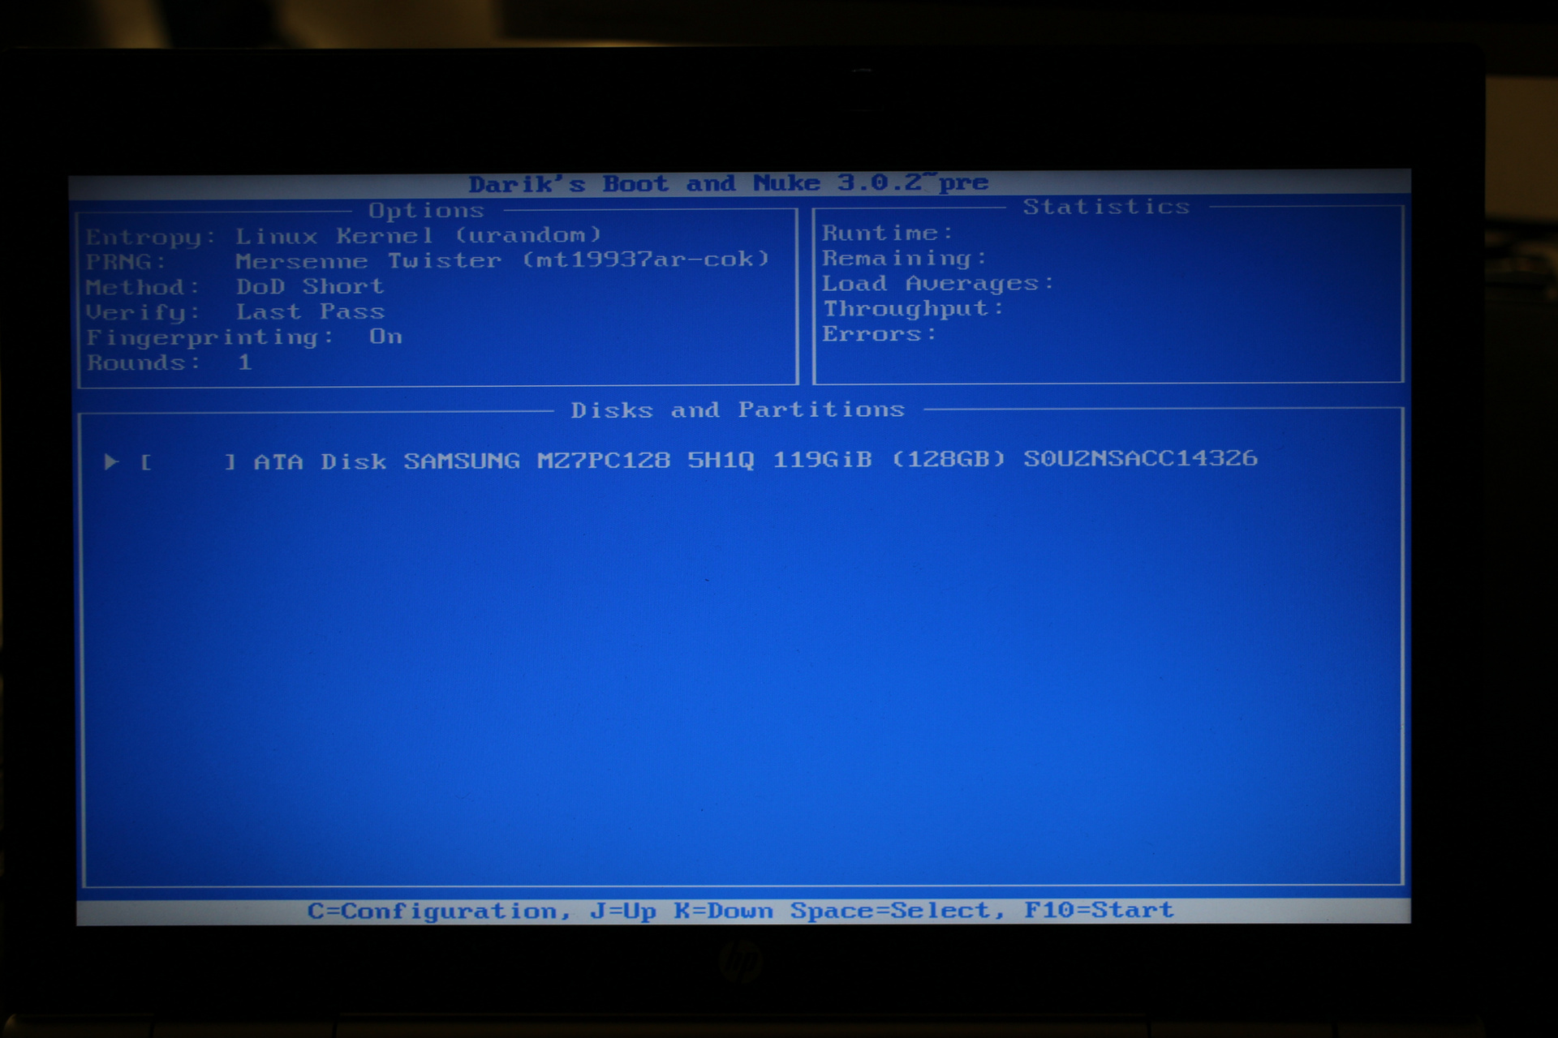
Use the space bar to select.
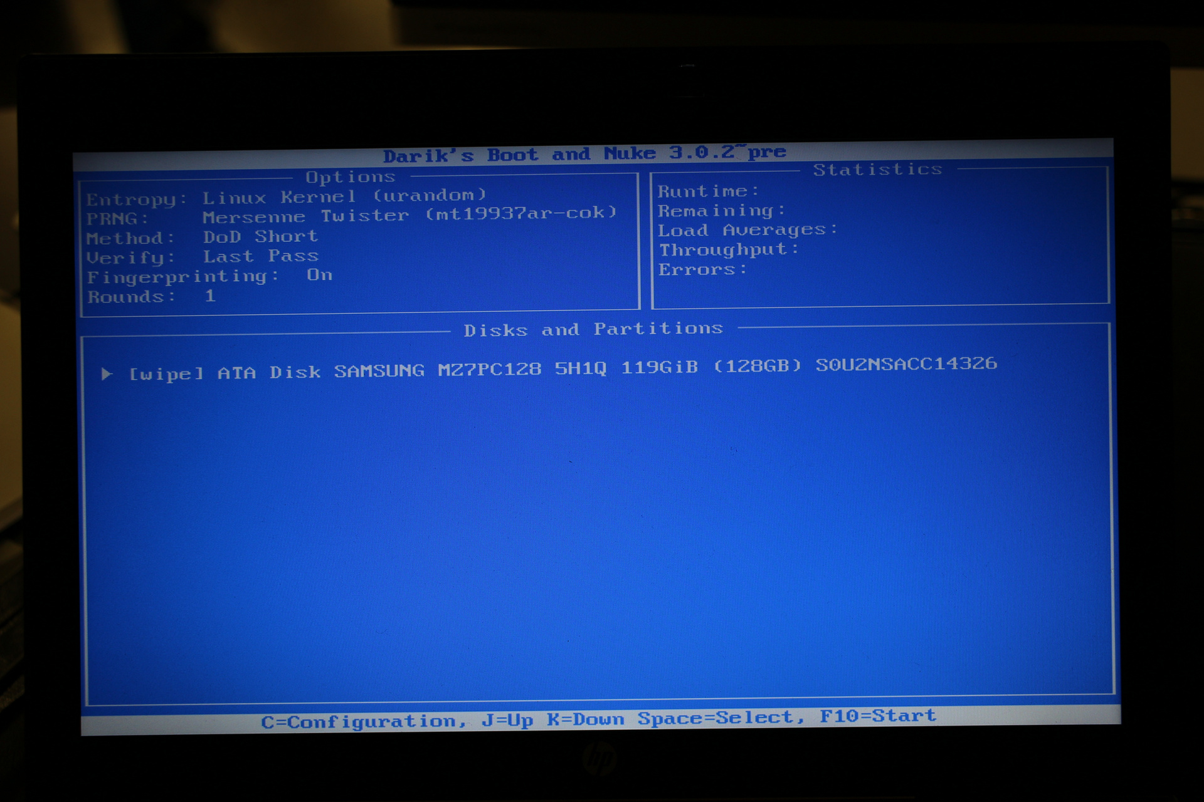
Then press enter to start the wipe. It will take about 50 for a 120gig drive.
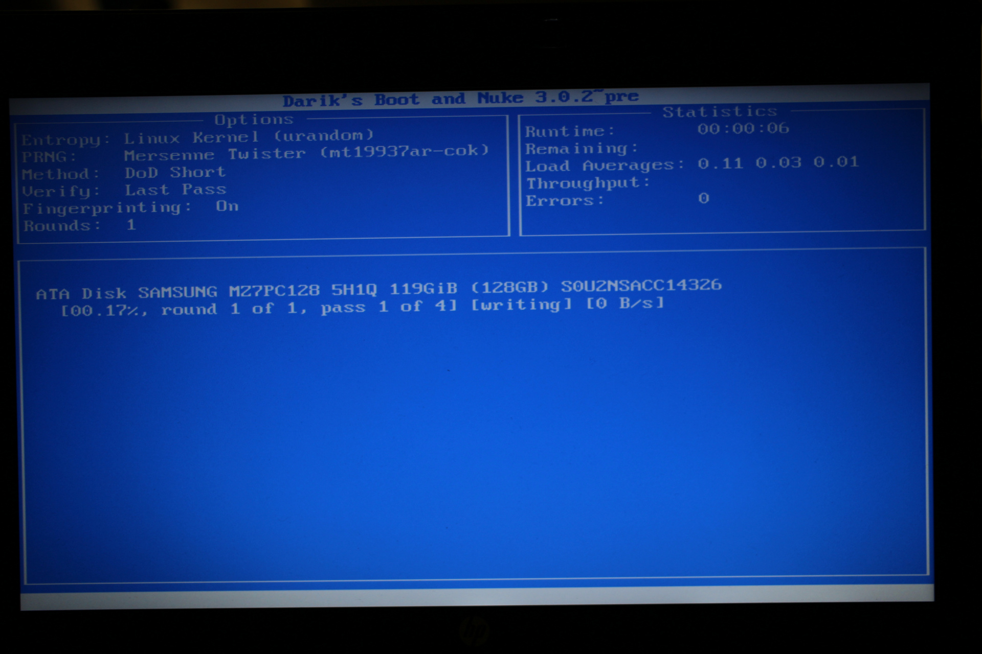

1) at this point we have had trouble with removable media bays (SD-CARD readers and the like) appearing as hard disks, which DBAN fails to mount, forcing it to hang. The solution is to disable the media bays in the BIOS

