Before the workshops start, approach your partner organisation for help with identifying workshops participants with special needs and/or mobility issues. If you have more than one facilitator, consider dedicating one to assisting these participants. Here is a photography form.
For the first workshop, the priority is on physically moving, taking apart and rebuilding the PCs, there is no need for power in this workshop for the participants.
Remember to keep one PC for the facilitators to work on, and a second to keep untouched to refer to during the rebuilding sections.
This workshop is a blend of physical trouble shooting and software installations. As with Workshop 01 before the workshop starts run through the check-list. Things to look out for
Before the workshop starts we need create the Xubuntu USB installers. You will need as many USB sticks as you have participants and a couple spare. The USB sticks should be at least 4gig in size.
First up lets grab the latest Xubuntu 14.0464bit image from our Australian mirror at aarnet.edu.au
We'll use gnome-disk-utility to write the Xubuntu Installer to our USB sticks. Install it with
sudo apt-get install gnome-disks
Launch it from the whisker menu.
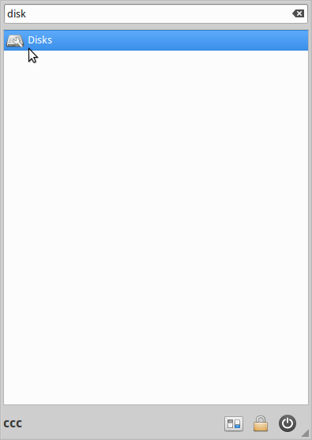Launch gnome-disk-utility
Insert your USB and select it in disk-utility.
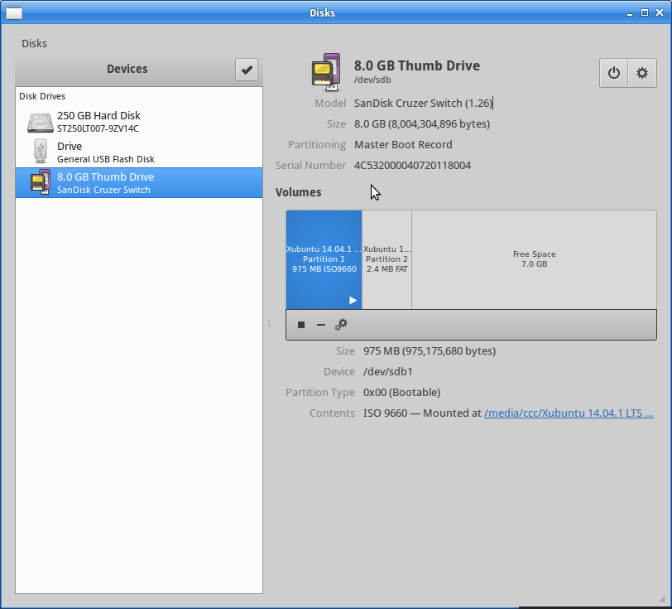Select USB
Select restore disk image form the top right.
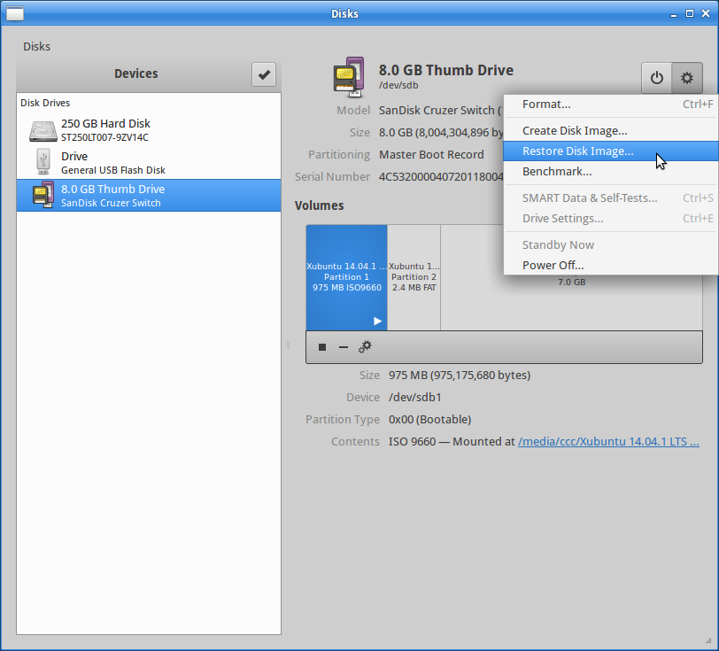Restore disk image
Now select the image you want to restore.
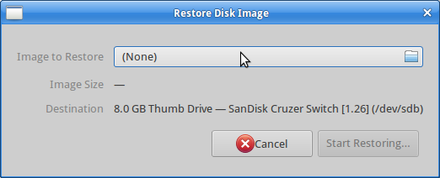Select image
You'll most likely find it in your downloads folder.
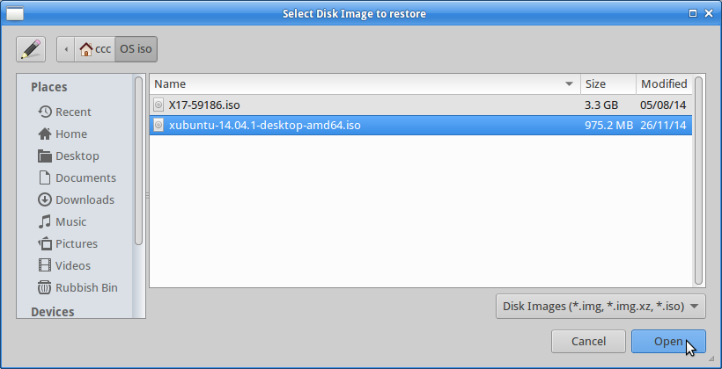Select Xubuntu
You will be warned here if your USB stick is too small - in this case we've got plenty of room. Click start restore.
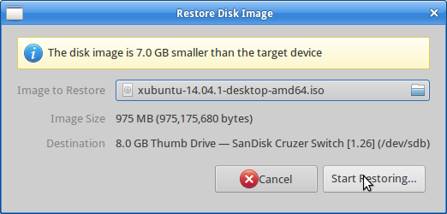Select Xubuntu
You will be asked if sure you want to continue.
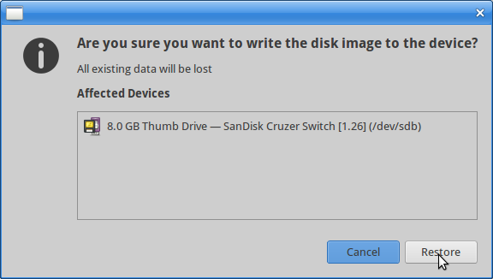Select Xubuntu
Enter your admin password.
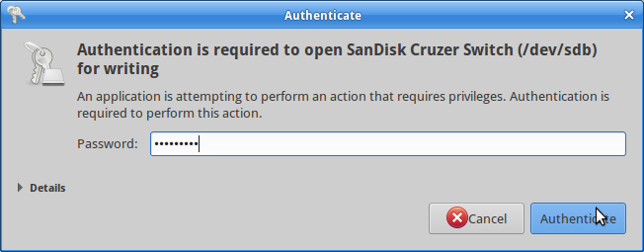Select Xubuntu
And after about 5 minutes you should be done.
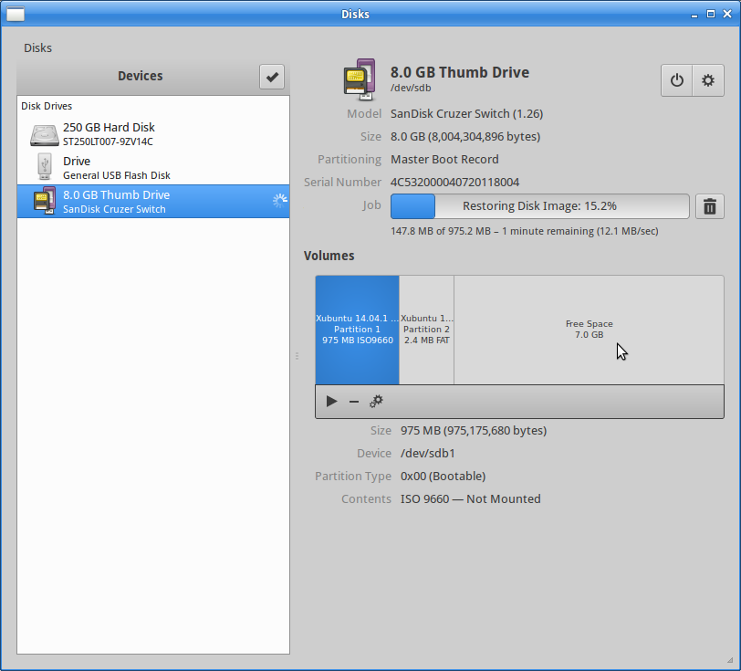Select Xubuntu
Setting up the LAN is a great way of involving participants in trouble-shooting as there will probably be some shuffling around needed and cables plugged and re-plugged. For a smaller workshop without the CCC-wifi your network will look like this;
You can make multiple USB images with a USB hub like this. follow the same procedure, but double check you are restoring to the right device!
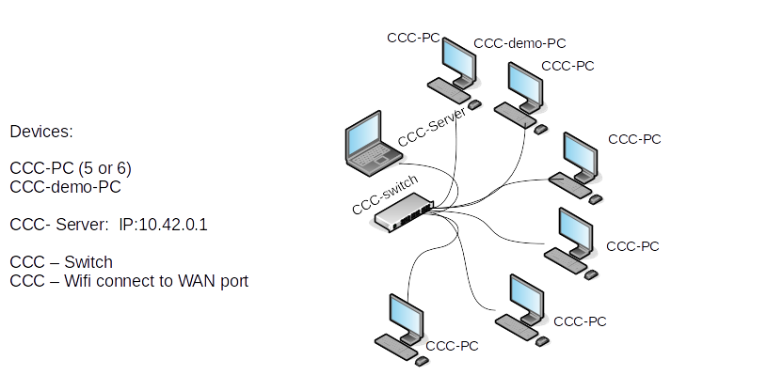
If you want to use CCC-wifi then try this;
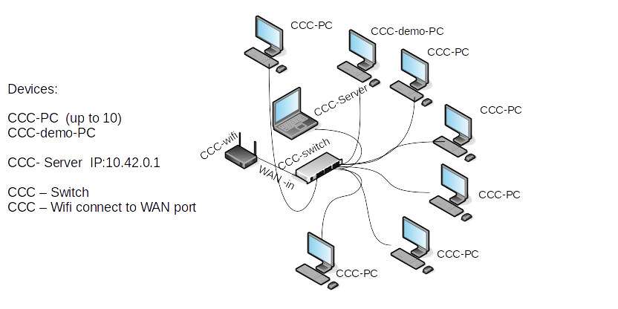
If you have a workshop with more than 15 CCC-PCs, or a large room to cover, you can use the CCC-wifi as a second switch to extend the network
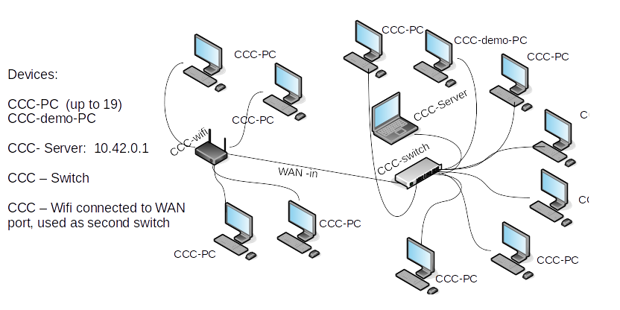
Here are some general instructions.
but be prepared for a bit of cabling chaos - warn your participants to watch their step until the cables are all taped down.
Prepare for Workshop 04 and 05

